


- Painting
- Collages
- Drawing

- Peacock Park
- Bat and ball games
- Playground games



Wraparound

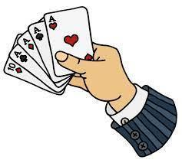

Breakfast : 7:30-8:45am
£7.00
Afternoon : 3:30-6:00 pm
£13.00

For more information about “Wraparound Care” contact us at:
wraparound@yardleyprimary.co.uk

- Board games
- Cards
- Puzzles



Run by Yardley Staff

